**THE SMART DUSTBIN USING ARDUINO**

**INTRODUCTION**

**Project Context**

A smart dustbin is a waste bin that incorporates sensors and smart technology to make waste management more efficient and environmentally friendly. It is designed to collect, and dispose of waste in a more sustainable and automated manner. The smart dustbin can also have features such as automatic lid opening, and even the ability to compact waste. These features reduce the need for manual intervention and make waste management more efficient and hygienic. The project context of a smart dustbin could include developing and designing a prototype with the necessary sensors, software, and hardware to achieve the desired functionality.

**Purpose and Description of the Project**

The purpose of a smart dustbin using Arduino is to create an automated system that can sort, organize, and dispose of waste effectively. The Arduino microcontroller is programmed to receive inputs from various sensors, such as infrared sensors, ultrasonic sensors, to detect the type of waste that is being disposed of. With this information, the Arduino can trigger the appropriate mechanism to sort and dispose of the waste. Smart dustbins using Arduino can be particularly useful in public places such as parks, schools, and offices, where it is challenging to manage the waste generated by a large number of people. Overall, a smart dustbin using Arduino can help create a more efficient, sustainable, and healthy environment by promoting better waste management practices.

**Objectives of the project**

The technical background of a smart dustbin project would involve understanding the hardware and software components required to build a working prototype. This could include sensors for waste level detection, motors for controlling the lid opening, and microcontrollers or other computing devices for processing data and controlling the device. The project would also require software development to enable the smart dustbin to communicate with other devices, such as waste management systems or mobile apps, and to analyze data from the sensors to optimize waste collection and segregation. Additionally, the project may require testing and validation of the smart dustbin in real-world scenarios to ensure its effectiveness and usability.

**TECHNICALITY OF THE PROJECT**

**Technicality of the project**

The smart dust bin, powered by Arduino, is equipped with sensors to identify objects in close proximity. A signal is then transmitted to a servo motor, which unhinges the lid. The motor is programmed to shut the lid after a certain duration.

**Details of the technologies to be used**

A smart dustbin typically involves a combination of hardware and software technologies to enable it to perform its functions effectively. Here are some of the key technologies that may be used in a smart dustbin:

1. Sensors: Smart dustbins typically use various types of sensors to detect the presence and type of waste. For example, infrared sensors can detect the presence of an object in the bin, while weight sensors can measure the amount of waste in the bin.
2. Internet of Things (IoT): Smart dustbins are often connected to the internet, allowing them to transmit data and receive commands. This connectivity allows for remote monitoring and control of the bin's functions.
3. Machine learning: Machine learning algorithms can be used to analyze the data collected by the sensors and make decisions about how to manage the waste. For example, a machine learning algorithm could classify the waste into different types and determine the appropriate disposal method.
4. Mobile applications: Some smart dustbins may be accompanied by mobile applications that allow users to monitor the status of the bin, receive notifications when the bin is full, and even request waste collection services.
5. Cloud computing: Cloud computing technologies can be used to store and process the data collected by the sensors, enabling real-time monitoring and analysis of the waste management system.
6. Robotics: Some smart dustbins may use robotic technology to sort and compact the waste, making it easier to transport and dispose of.

Overall, the combination of these technologies can enable smart dustbins to improve waste management practices, reduce environmental impact, and promote sustainability.

**How the project will work**

The project will work using by Arduino Uno, an ultrasonic sensor, a servo motor and a battery jumper wire. Also the code that we used.

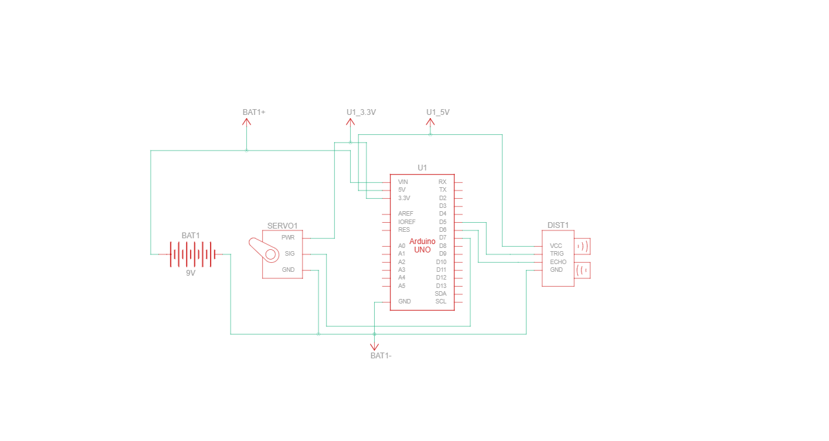**Circuit diagram of the project**

**Methodology**

**Data and Process Modeling**

* **Context Diagram**

The context diagram shows three main components: the Smart Dustbin, the User, and the Cloud Server.

The Smart Dustbin is the main component of the system and is responsible for collecting and storing waste. It is equipped with various sensors that allow it to detect the type and quantity of waste that has been deposited. It also has a connection to the internet, which allows it to send data to the Cloud Server.

The User is the person who interacts with the Smart Dustbin. They deposit waste into the dustbin and can also access information about the amount and type of waste that has been collected.

The Cloud Server is the central component of the system. It receives data from the Smart Dustbin and processes it. It can provide real-time information about the status of the dustbin, including the amount and type of waste that has been collected. It can also send notifications to the User when the dustbin needs to be emptied.

* **Data Flow Diagram**

   The Arduino Smart Dustbin is a device that automates waste management by detecting the presence of waste and opening/closing the dustbin . The software controls the various components of the system, including sensors, actuators, and communication modules.

* **System Flowchart**

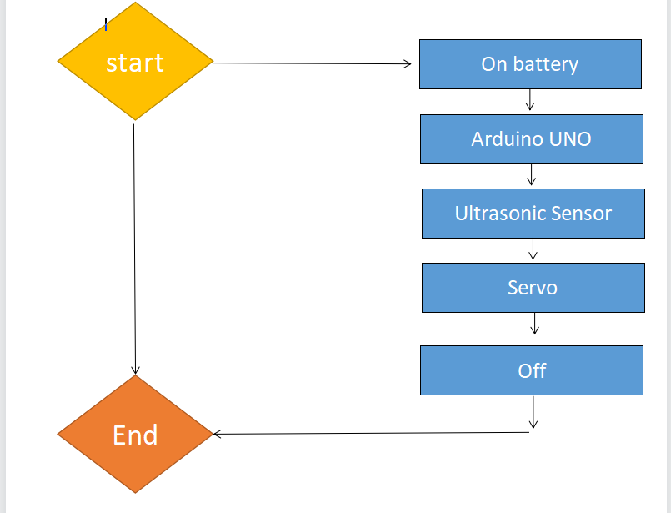

* **Parts and equipment needed**

This combo containing all products needed to make a smart dustbin that opens automatically when someone comes near to the dustbin. The Arduino Uno R3 Compatible Board is a microcontroller board that is based on the ATmega328. Arduino Uno has 14 digital input or output pins, 6 analog inputs, a 16 MHz ceramic resonator, a USB connection, a power jack, an ICSP header, and a reset button. It has everything needed to support the microcontroller, you need to simply connect it to a computer with a USB cable or power it with an AC-to-DC adapter or battery to get started. This HC-SR04-Ultrasonic Distance Measuring Sensor is a very popular sensor that is found in many applications where it requires measuring distance and detect objects. The HC-SR04 ultrasonic sensor uses sonar to determine the distance to an object like bats or dolphins do. The module has two eyes-like projects in the front which form the Ultrasonic transmitter and Receiver. The Micro Servo 9G is lightweight, high-quality, and lightning-fast. The servo is designed to work with almost all radio control systems. It is with excellent performance that brings you to another horizon of flight. This is the combo of 20CM Wire Color Jumper Cable, M-M, M-F, F-F 10PCS of wire in each strip of cable. It is very flexible and easily detachable to no. of wires to your requirement. Mostly it can be used for Orange Pi, Banana Pi, Raspberry Pi, Arduino, and other mini PC and development boards. This is a general 9v Battery With Battery Snap Connector to DC barrel jack adapter for all your project and application needs. One can use this adapter to power up any DC barrel jack-based power connector using a standard 9V battery.

* **Software Specification**
* **Installation process**
* Step 1: we gathered all the materials needed like ultrasonic sensor, Arduino, servo, jumper wires, and battery
* Step 2: Next we do is we connect the Arduino to Ultrasonic sensor
* Step 3: We also connect Arduino to Servo
* Step 4: We connect Switch and battery
* Step 5: Fix the servo pully
* Step 6: We fix our material and do a diy trashcan
* Step 7: code upload
* Step 8: and it's ready to use.

**Testing**

* **User guide**

**User Guide: Smart Dustbin Using Arduino**

**Introduction:**

**The smart dustbin is an innovative project that utilizes Arduino, an open-source electronics platform, to create an intelligent and automated waste disposal system. This user guide will provide step-by-step instructions on how to set up and use the smart dustbin.**

**Components Needed:**

**Arduino Uno**

**Ultrasonic sensor**

**Servo motor**

**Jumper wires**

**Breadboard**

**USB cable for Arduino**

**Power supply (e.g., 9V battery)**

**Dustbin or container or any recyclable materials that can create a bin**

**Step 1: Hardware Setup**

**1. Connect the Arduino board to your computer using the USB cable.**

**2. Place the Arduino board on the breadboard.**

**3. Connect the VCC pin of the ultrasonic sensor to the 5V pin on the Arduino.**

**4. Connect the GND pin of the ultrasonic sensor to the GND pin on the Arduino.**

**5. Connect the trig pin of the ultrasonic sensor to pin 9 on the Arduino.**

**6. Connect the echo pin of the ultrasonic sensor to pin 10 on the Arduino.**

**7. Connect the VCC pin of the servo motor to the 5V pin on the Arduino.**

**8. Connect the GND pin of the servo motor to the GND pin on the Arduino.**

**8. Connect the signal pin of the servo motor to pin 11 on the Arduino.**

**9. Make sure all connections are secure and properly connected.**

**Step 2: Software Setup**

**1. Download and install the Arduino IDE**

**2. Open the Arduino IDE.**

**Select the appropriate board and port from the "Tools" menu.**

**3. Open a new sketch and input the code.**

**4. Verify the code for any errors by clicking the checkmark icon.**

**5. Upload the code to the Arduino board by clicking the right arrow icon.**

**Step 3: Assembling the Smart Dustbin**

**1. Attach the ultrasonic sensor to the top of the dustbin, facing downwards.**

**2. Mount the servo motor inside the dustbin, ensuring it can open and close the lid.**

**3. Make sure the servo motor's arm is connected to the lid or cover of the dustbin.**

**4. Ensure the ultrasonic sensor has a clear line of sight to detect objects.**

**Step 4: Testing and Usage**

**1.Power up the Arduino board using a power supply**

**2. Try using it.**

**Documentary**